**DAILY ONLINE ACTIVITIES SUMMARY**

|  |  |  |  |  |  |  |  |  |
| --- | --- | --- | --- | --- | --- | --- | --- | --- |
| **Date:** | **03/07/2020** | | | | | **Name:** | **RITIKA R KULKARNI** | |
| **Sem& Sec** | **4​th​ SEM. & ‘B’ SEC.** | | | | | **USN:** | **4AL19CS403** | |
| **Online Test Summary** | | | | | | | | |
| **Subject** | | **- -** | | | | | | |
| **Max. Marks** | | **--** | | **Score** | | | **- -** | |
| **Certification Course Summary** | | | | | | | | |
| **Course** | **Learn Web Design: The Ultimate Guide For Beginners** | | | | | | | |
| **Certificate Provider** | | | **BitDegree** | | **Duration** | | | **7 Hrs.** |
| **Coding Challenges** | | | | | | | | |
| **Problem Statement:------** | | | | | | | | |
| **Status: ------** | | | | | | | | |
| **Uploaded the report in Github** | | | | | **----** | | | |
| **If yes Repository name** | | | | | ------- | | | |
| **Uploaded the report in slack** | | | | | **----** | | | |

**Online Test Summary:** No internals conducted.

**Online Certification course Summary​:**I have taken new Online Certification Course in **BitDegree** . Today I went through Design for Coders in that I learned Typography Clarendon and I got certificate.

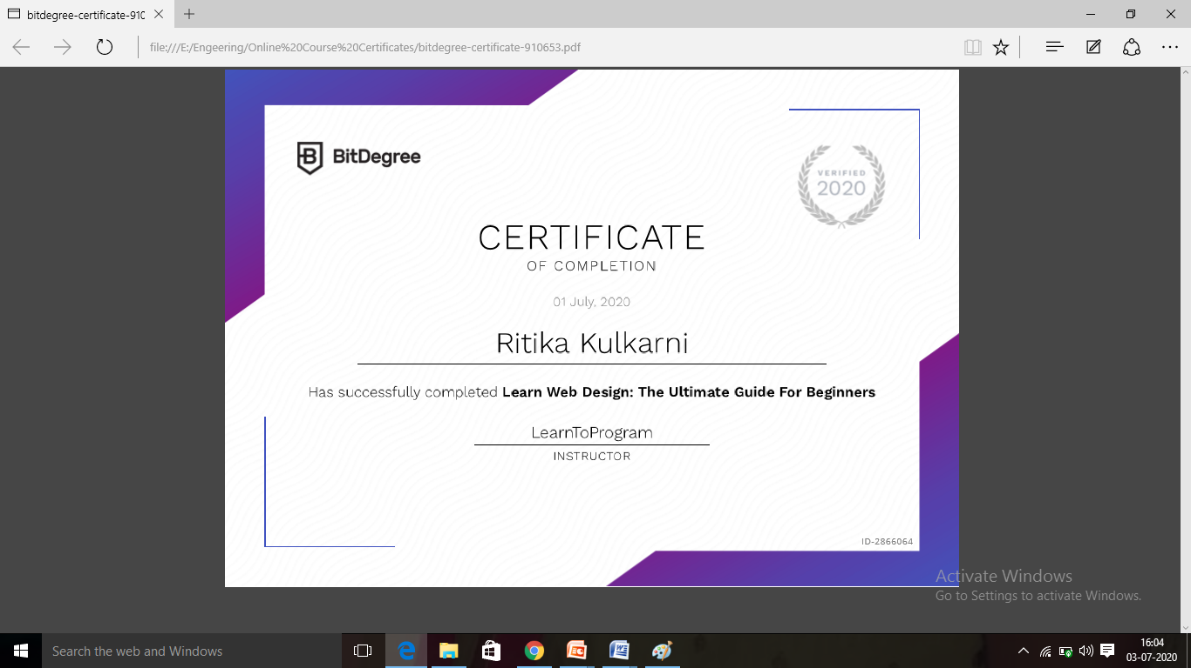

**Online Training**: Today I had attended the online training organized by CSE Dept AIET. The training was on C programming done by Prof. Megha Hegde CSE Dept. After the session the quiz was conducted. the snapshot that shown in below quiz attempted and the marks obtained.

